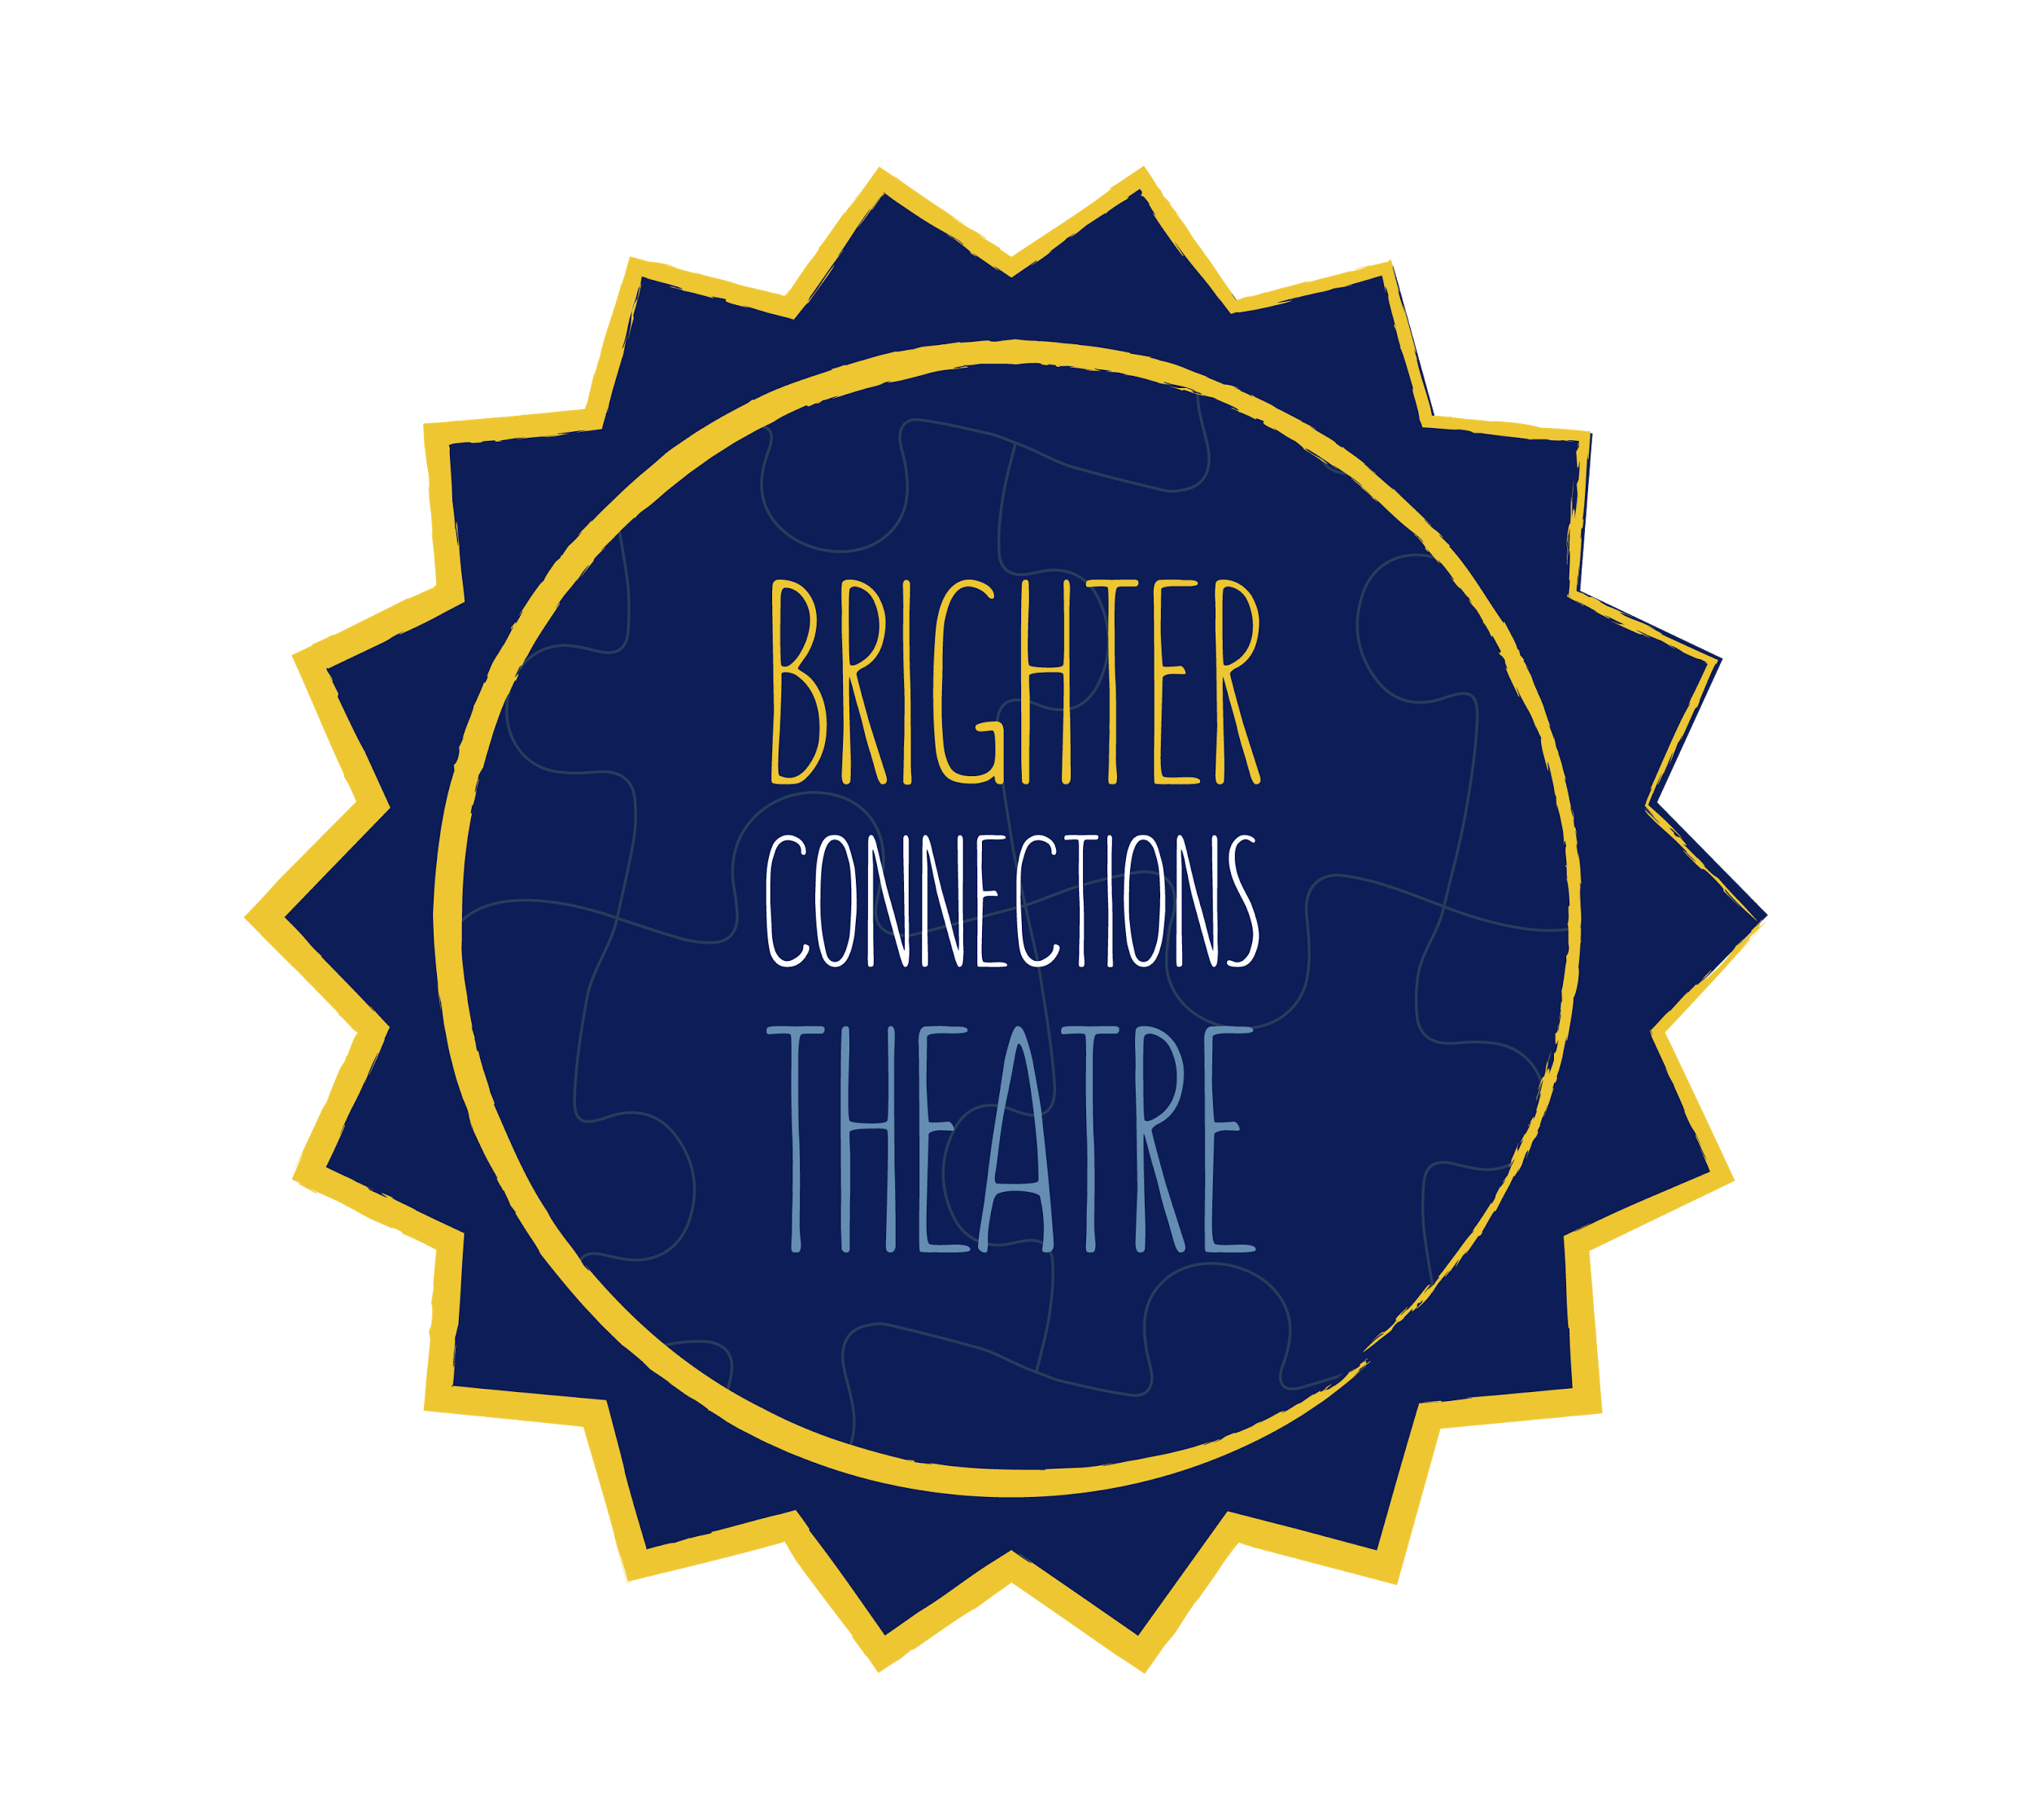
2019 Cast Member Registration Materials
- Welcome Letter
- Scholarship Resources
- BCT Registration Form
- Schedule

Hello BCT Friends and Family,

We hope you and your families are getting excited for summer! Here at Brighter Connections Theatre, we are preparing for our 7th annual season of programming in collaboration with the University of Dayton Theatre, Dance, and Performance Technology Program, and we hope you will join us! Detailed information is included below regarding both programs:

Youth Program: Designed for students ages 8 through 14, this program runs for 6 weeks beginning on Tuesday, June 4, 2019. Rehearsals take place every Tuesday, Wednesday, and Thursday from 6:00 pm until 7:30 pm. During rehearsals, students will work with between 6-8 trained volunteers and staff members to create their very own show that will premier the weekend of July 12-14, 2019. What sets this program apart from a typical youth theatre experience is the individual attention we are able to provide our participants. 15-20 cast members will be working together to achieve social, behavioral, and communication goals over the course of the six weeks. We combine theatre elements such as role play and educational best practices to create both an effective and creative learning environment.

Cost: $40

Young Adult Program: Designed for students ages 15-18, this program will run for 6 weeks beginning on Tuesday, June 4, 2019. Rehearsals will take place every Tuesday, Wednesday, and Thursday from 4:30 to 6:00 pm. During rehearsals, students will work with between 6-8 trained volunteers, peer models, and staff members to create their very own show that will premier the weekend of July 12-14, 2019. The purpose of this 6 week program is to provide our high school aged students an opportunity to interact with peers in a safe, accommodating, and flexible environment. Participants will focus on social and independency skills.

Cost: $40

Location: For the fourth year in a row, BCT will be collaborating with the University of Dayton’s Department of Theatre, Dance, and Performance Technology. All rehearsals and performances will take place in Fitz Hall on 1529 Brown St. Dayton, OH 45409.

Registration materials can be mailed to:
Brighter Connections Theatre, Inc.
1157 Greystone Cir.
Dayton, OH 45414

OR emailed to bctdayton@gmail.com

Please note that all performance dates, including the dress rehearsal, are mandatory for all cast participants and volunteers. By registering your child, you are agreeing to be in attendance for all performances.

Important Dates for Youth and Young Adult Casts
Parent Meeting: Monday, June 3 at 6:00 pm
Mandatory Tech Rehearsals: July 9, 10, and 11
Youth Performances: July 13 & 14 at 2:00 pm

Young Adult Performances: July 13 & 14 at 5:00 pm

For those of you returning this summer or registering for the very first time, we cannot wait to see you! Please contact Katie using the information below at any time with questions or concerns.

Brighter Connections Theatre 2019 Staff
bctdayton@gmail.com
937.469.0628
Scholarship Resources

Autism Society of Dayton
https://autismsocietyofdayton.org/grants/
You can access a grant application on the Dayton Autism Society website or using the above link.

MyGoal, Inc.
http://mygoalautism.org/mygoal-resources/#grants
Enrichment Grants can be requested. Grants are typically due in March.

DDS Family Support Services
If your child is eligible for your county board of Developmental Disability Services (DDS) Family Support Services funding, please contact Sandy Schutte at Sandy.Schutte@swocog.org for an application for funding. Applying as early as possible in the year is highly recommended.

Cast Member Registration Form
BCT is limited in the number of participants we may accept. Registration will be on a “first come, first served” basis. Filling out this form does not guarantee that there is space available. If you would like to know more before you register, please contact Katie O’Leary using the email provided below.
Students between the ages of 8 and 14 will be placed in the Youth program. Students 15-18 will be in the Young Adult program. S/he must also be able to attend the majority of rehearsals held on Tuesday, Wednesday, and Thursday evenings beginning the week of June 4, with mandatory attendance on July 8- July 13. Please submit this form or any questions to bctdayton@gmail.com
Child’s Name:
Age:
Year in School:
School District:
Home Address:

Diagnosis (optional):

Hobbies:

Successful rewards and incentives:

Parent(s)/Guardian Names:
Phone Number:
Email Address(es):
Please list any and all individuals who are authorized to pick up your cast member(s) from rehearsal:
_____________________________
_____________________________
_____________________________
_____________________________
_____________________________

We will hold our Parent Meeting on Monday, June 3 6:00 to 7:00 pm. This meeting is important for both new and returning members. You may pay registration fees this night and we will be discussing new ticketing procedures, expectations, and the outline of rehearsals with larger casts being split into smaller groups. We encourage bringing your cast member this evening as s/he will get a chance to play games and visit the theatre with the staff and volunteers!
Please check one of the following:
- YES, I will plan on attending the Parent Meeting.

- No, I know I will not be able to attend the Parent Meeting and will need a different method of communication for this information.

